**DAILY ONLINE ACTIVITIES SUMMARY**

|  |  |  |  |  |  |  |  |  |
| --- | --- | --- | --- | --- | --- | --- | --- | --- |
| **Date:** | **27-06-2020** | | | | | **Name:** | **Deril Quadras** | |
| **Sem & Sec** | **8 A** | | | | | **USN:** | **4AL16CS031** | |
| **Online Test Summary** | | | | | | | | |
| **Subject** | | **-** | | | | | | |
| **Max. Marks** | | **-** | | **Score** | | | **-** | |
| **Certification Course Summary** | | | | | | | | |
| **Course** | **AWS Deep Dive on Container Security.** | | | | | | | |
| **Certificate Provider** | | | **AWS** | | **Duration** | | | **30 mins** |
| **Coding Challenges** | | | | | | | | |
| **Problem Statement:**   1. **Write a C Program to implement Pointer** | | | | | | | | |
| **Status: Solved** | | | | | | | | |
| **Uploaded the report in Github** | | | | | **Yes** | | | |
| **If yes Repository name** | | | | | **Derilquadras/online_c_coding_repository** | | | |
| **Uploaded the report in slack** | | | | | **Yes** | | | |

Online Test Details:

Not Conducted

Certification Course Details:

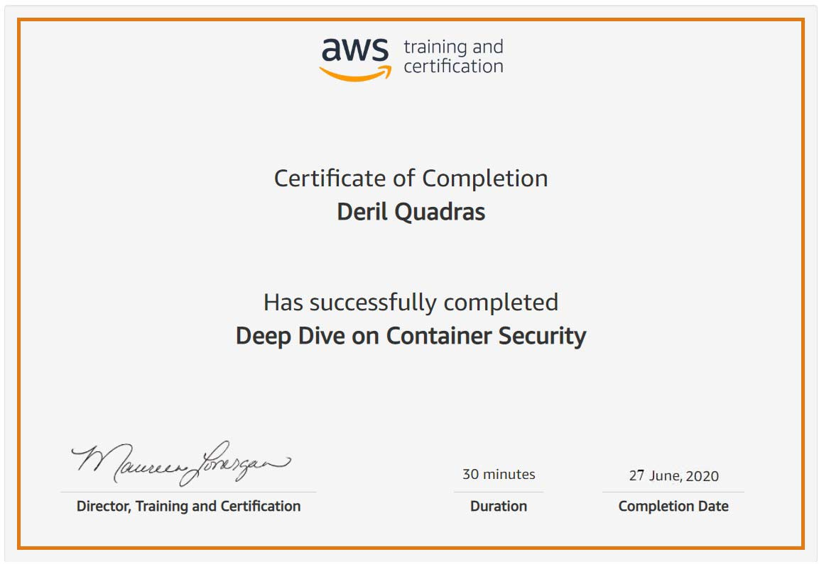

Coding Challenges Details:

**PROGRAM 1 .**

**//Pointer**

**#include <stdio.h>**

**int main()**

**{**

**int x, y, *a, *b, temp;**

**printf("Enter the value of x and y\n");**

**scanf("%d\n%d\n", &x, &y);**

**printf("%d\n%d\n",x,y);**

**printf("Before Swapping\nx = %d\ny = %d\n", x, y);**

**a = &x;**

**b = &y;**

**temp = *b;**

**\*b = *a;**

**\*a = temp;**

**printf("After Swapping\nx = %d\ny = %d\n", x, y);**

**return 0;**

**}**